**ARYAMAN MISHRA**

**19BCE1027**

**EXPERIMENT 11-ARMITAGE**

Use ifconfig command to find IP address of device.

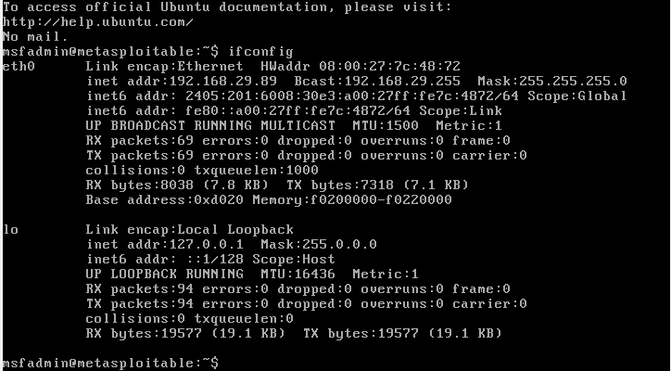

Launch Armitage on Kali Linux(pre-installed).

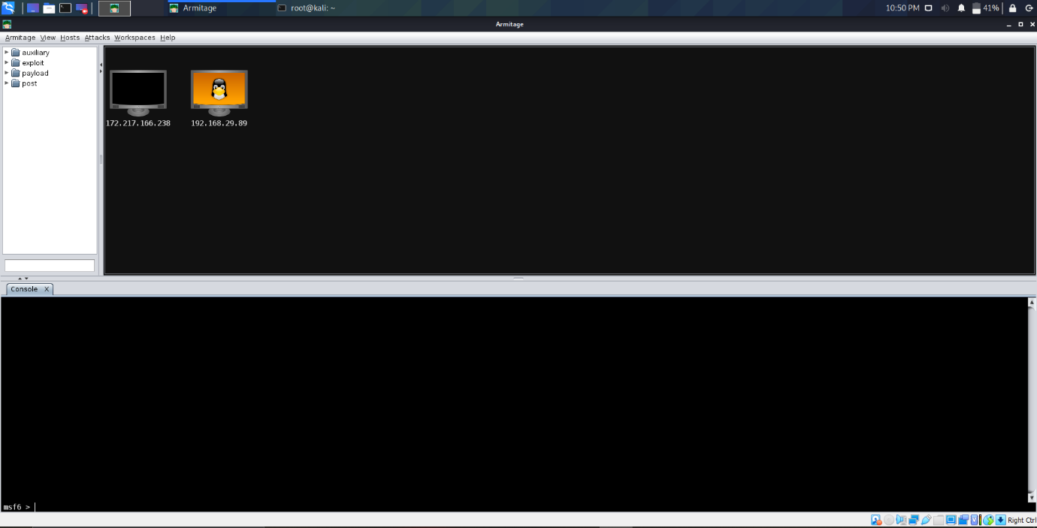

1)Execute vsfpd_234_backdoor exploit.

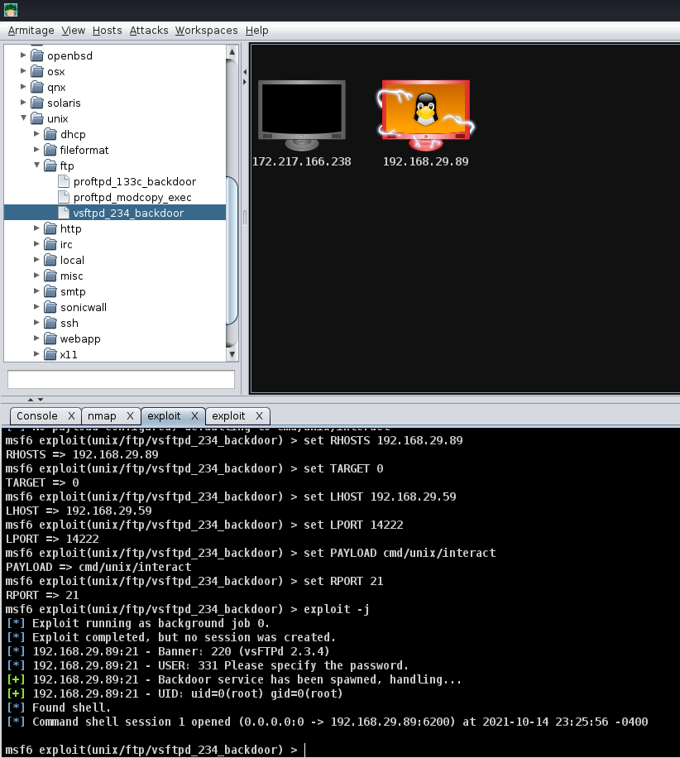

Execute the exploit on metasploitable VM and access files on the virtual machine using Armitage.

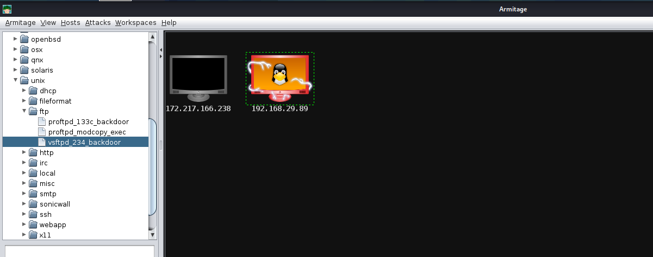

Access files in Shell 1 using ls command

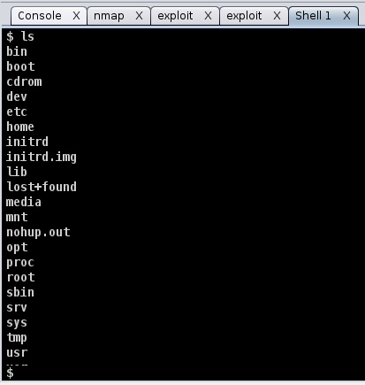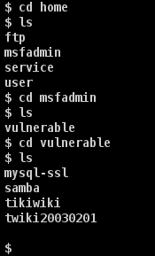

Access home directory on metasploit.

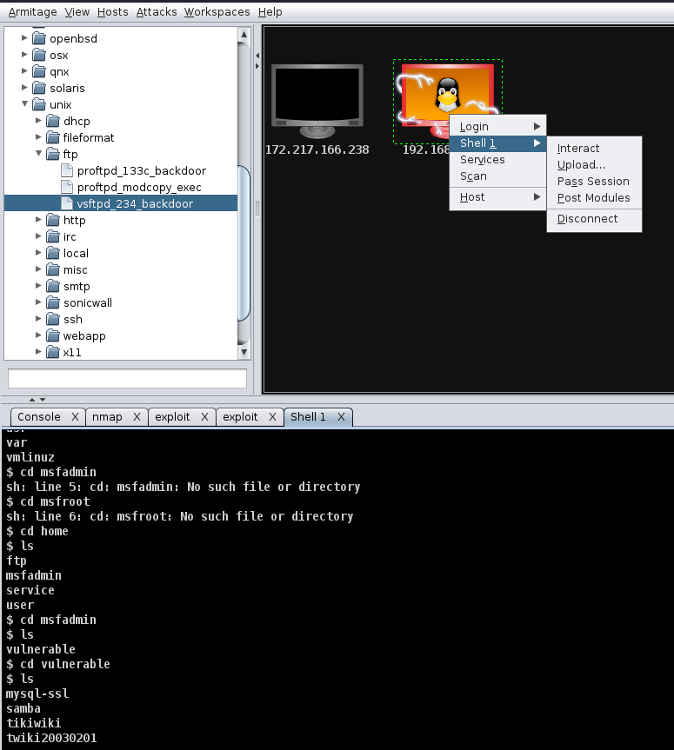

2)Complete Attack Analysis in Armitage to carry out more exploits and attacks.

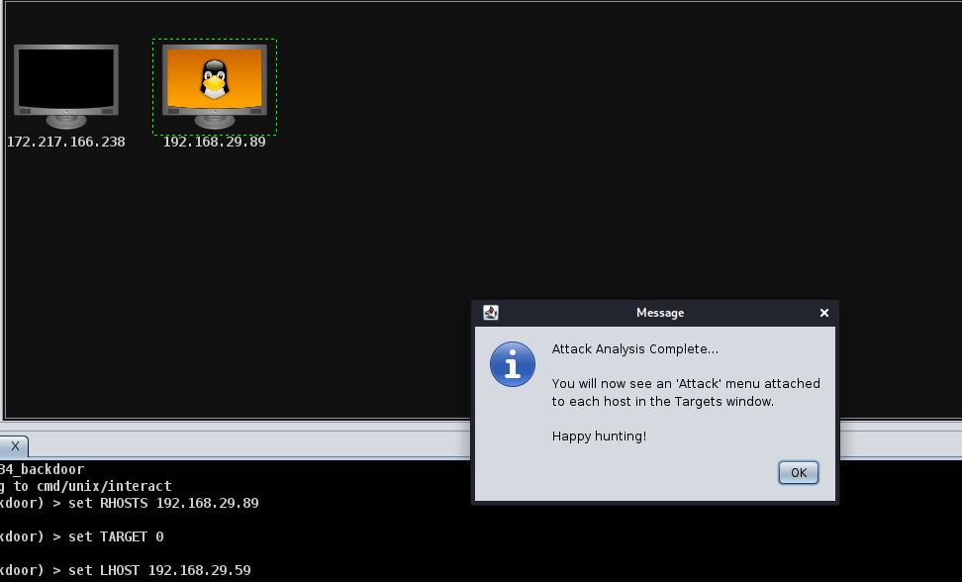

2)Reverse UDP.

Assign LHOST,LPORT,PAYLOAD AND SESSION DETAILS by performing exploit on Windows Machine on a different network.

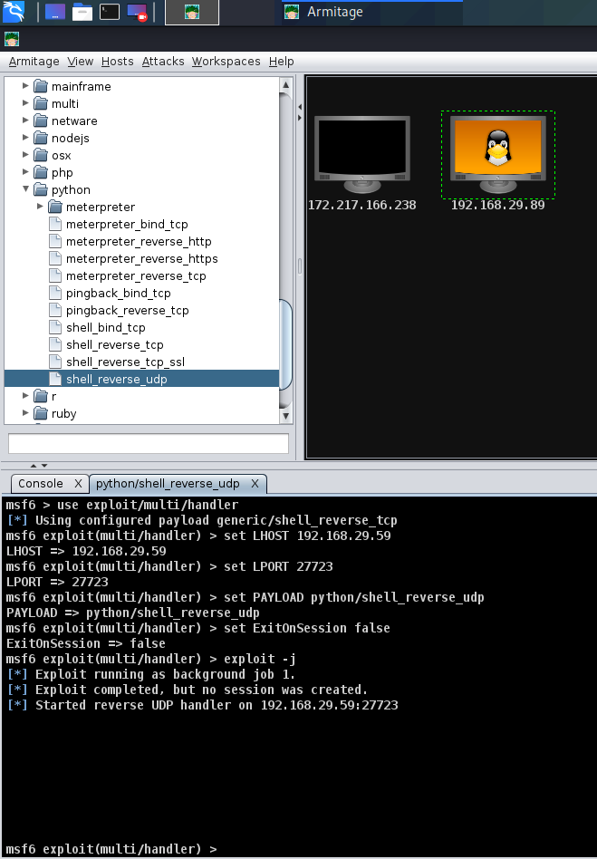

3)FTP

Assign RHOST,PASSWORD,BLANK_PASSWORDS,USERNAME,USER_AS_PASS and PORT details of Metasploit VM on the same device and perform exploit using Armitage.

